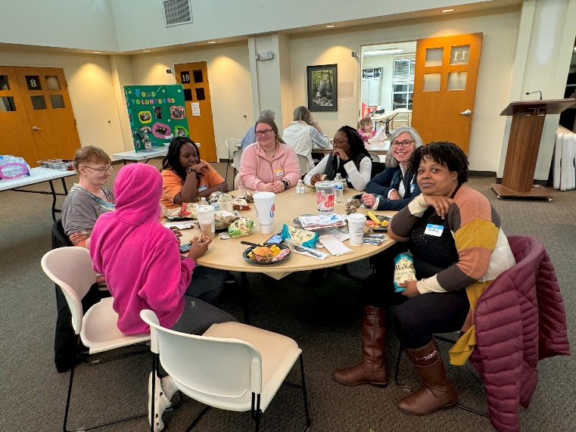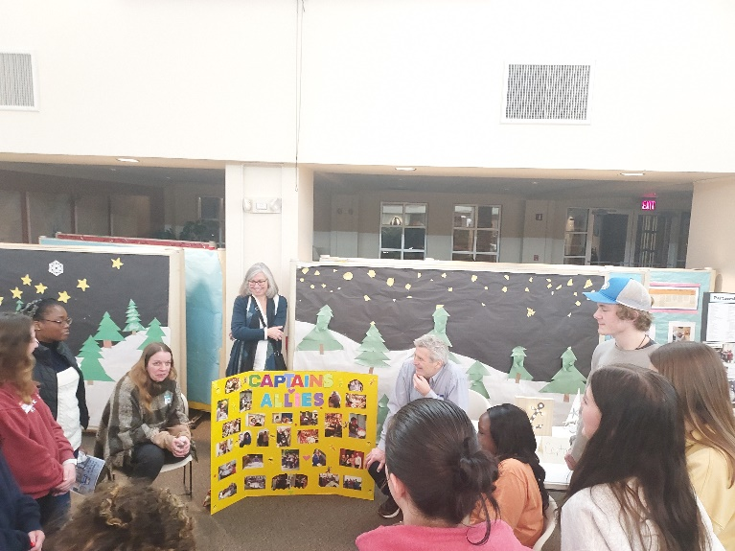
Thriving Connections is an intentional way for people to build relationships across economic class and race lines to end poverty in their communities.

When? Weekly community meetings are most Thursdays from 6-8pm
Where? St. Mark’s United Methodist Church
Why? All the money and programs in the world cannot equal the power of one relationship built on equality and love.
- SCCAP website: https://www.insccap.org/pages/thrivingconnections
- “Like” SCCAP Thriving Connections on Facebook http://www.fb.me/SCCAPThrivingConnections
- YouTube https://www.youtube.com/channel/UC-XkNLEcBjj1M8sC3uXtY5g

For more information contact:
Katie Hopkins, Thriving Connections Manager khopkins@insccap.org

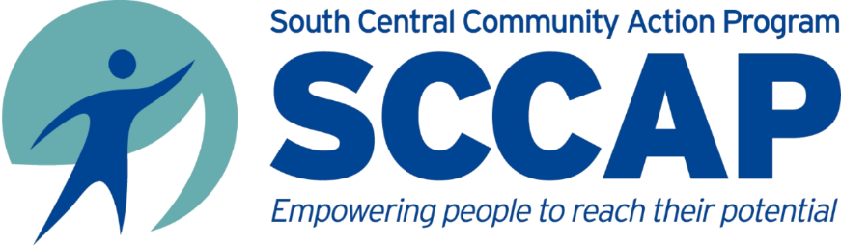
Volunteer Opportunities
Come join the TC fleet of ships as we sail the seas of life!
Captains (people working their way out of poverty) pilot their ship with a crew, charts & resources to support them. How can you support our Captains?
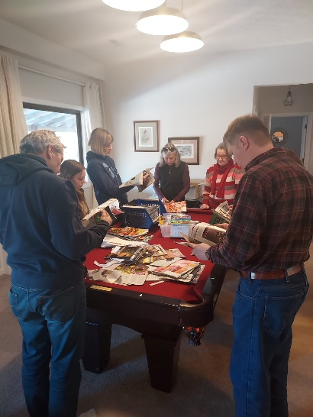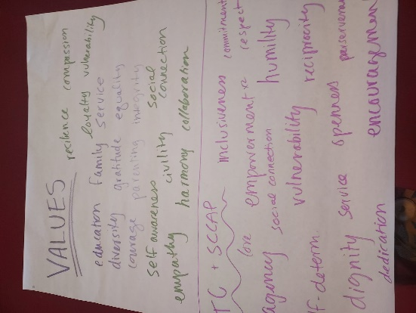
Be an Ally! As an Ally, you will provide friendship, acting as a sort of extended family member to a person or family living in poverty. You and your ship will work together to accomplish specific goals set by the Captain in order to increase his or her resources. As you walk alongside your Captain, you will provide valuable knowledge and insight relating to a variety of life circumstances, whether it is financial or educational input, or social connections. We ask that you commit to your Ship for 18 months. You will also learn to see poverty in a different light, dispelling stereotypes about people who live in poverty.
Be a Guiding Coalition Member! The Guiding Coalition is an advisory group that includes people from all economic classes who are committed to building community and ending poverty. You can serve on one of our six advisory groups: Economic Stability, Captain & Ally, Funding, Recruitment & Outreach, Youth Advisory Group, and our newest groups. One addressing issues that intersect poverty such as racial justice, disability and other isms--Talking about Change and the other focusing on all things Technological.
Be a Youth Volunteer! Children of all ages participate in fun, educational activities of all different kinds. We are always looking for responsible, fun, and friendly volunteers to assist with the Youth Community.
Lead Adult Programming! If you have an idea for a discussion or presentation for a Thursday night meeting, let us know! We’ve hosted programming ranging from dance groups and locally owned farms to IU professors and panels of MCCSC school board and staff members.
Lead Youth Programming! If you would like to lead an activity or share a special talent with one of our youth community groups, we’d love to hear from you! We try to align youth programming with adult programming, if possible.

All SCCAP services are provided without regard to race, age, color, religion, sex, gender identity, gender expression, genetic information, sexual orientation, marital status, disability, national origin, ancestry, or status as a veteran.

